WHY FITMAS? This time of year it's almost impossible to avoid parties with buffets of tasty food and drink. But all of that indulging can have a downside: holiday weight gain.

The average person gains 1.7 pounds between Thanksgiving and New Year's, according to a 2009 study. But we're going to make good use of our time and focus on staying healthy during the holidays!

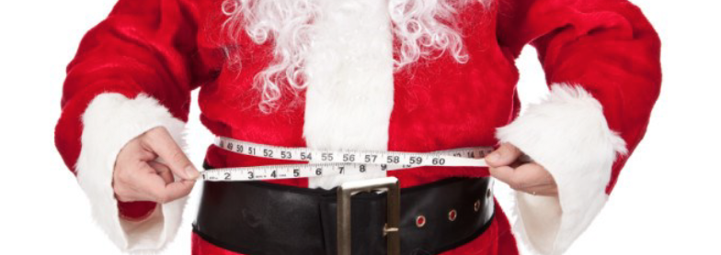

DAY 0: INVITES
Want to stay in shape over the holidays, but not sure where to start? I've got you covered with the 12 Days of Fitmas Challenge. Join us to get a daily dose of quick exercises you can fit into your hectic schedule! #MerryFitmas!!

DAY 1: (When you complete the challenge, post a selfie and/or post a comment below 👇👇)

🎶On the FIRST day of FITmas, the challenge I give to you: 1-Minute Wall Sit (repeat 3 times) 🎶

How? Start by standing about 2 feet away from a wall with your back against the wall. Slide your back down the wall until your hips and knees bend at a 90 degrees angle. Keep the shoulders, upper back and the back of the head against the wall. Both feet should be flat on the ground with the weight evenly distributed.

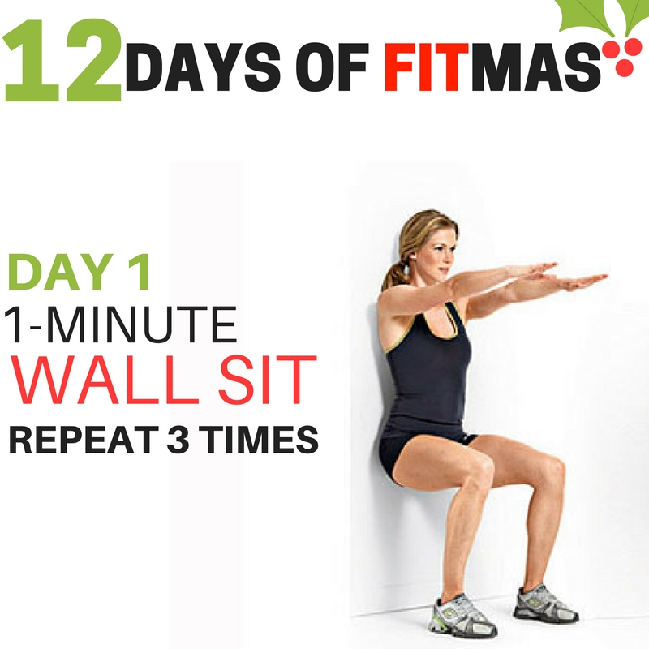
DAY 2: (When you complete the challenge, post a selfie and/or post a comment below 👇👇)

🎶On the SECOND day of FITmas, the challenge I give to you: 2 x 45-Second Planks (repeat 3 times) 🎶

How? Start by getting into a push-up position. Bend your elbows and rest your weight ono your forearms and not on your hands. Your body should form a straight line from shoulders to ankles. Engage your core by sucking your belly button into your spine. Hold this position for the prescribed time. Modify by dropping to your knees.

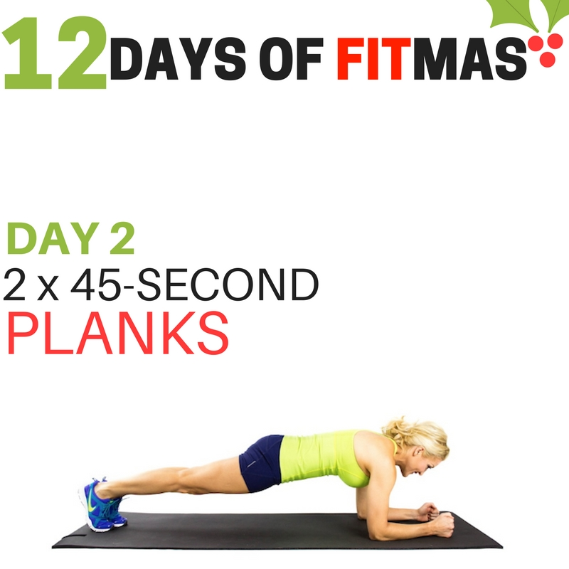

DAY 3: (When you complete the challenge, post a selfie and/or post a comment below 👇👇)

🎶On the THIRD day of FITmas, the challenge I give to you: 3 Sets of 25 Jumping Jacks🎶

How? Stand with your feet together and your hands down by your side. In one motion jump your feet out to the side and raise your arms above your head. Immediately reverse that motion by jumping back to the starting position.
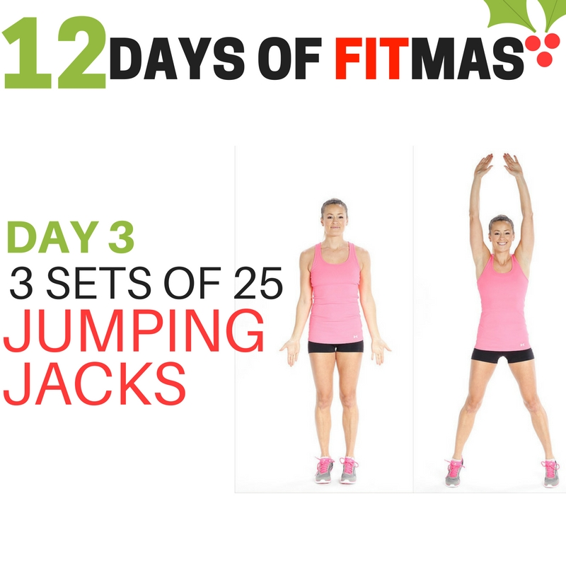
DAY 4: (When you complete the challenge, post a selfie and/or post a comment below 👇👇)

🎶On the FOURTH day of FITmas, the challenge I give to you: 4 Sets of 25 Crunches🎶

How? Lie on your back with your knees bent and feet flat on the floor, hip-width apart. Place your hands behind your head so your thumbs are behind your ears. Hold your elbows out to the sides but rounded slightly in. Tilt your chin slightly, leaving a few inches of space between your chin and your chest. Gently pull your abdominals inward. Curl up and forward so that your head, neck, and shoulder blades lift off the floor. Hold for a moment at the top of the movement and then lower slowly back down.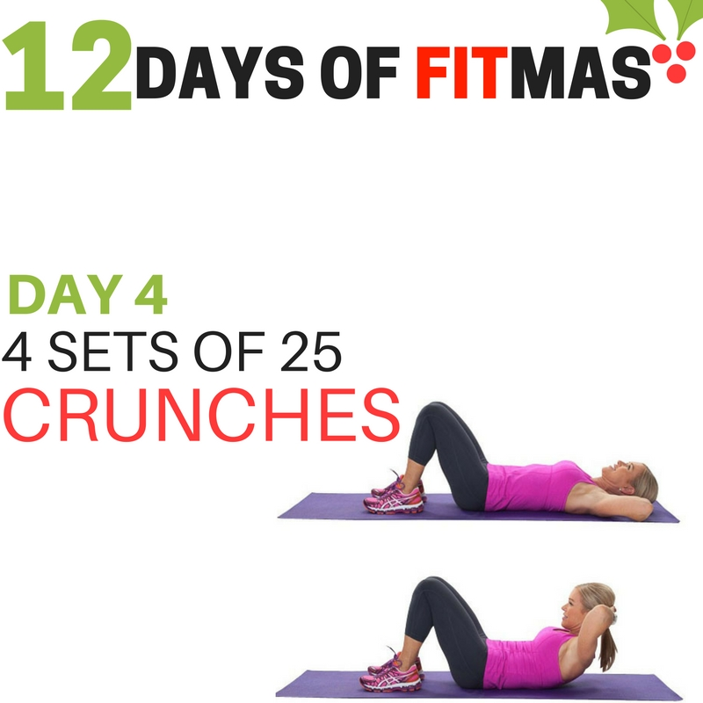
DAY 5: (When you complete the challenge, post a selfie and/or post a comment below 👇👇)

🎶On the FIFTH day of FITmas, the challenge I give to you: Five x 15-Second Side Planks On Each Side🎶

How? Start on your side with your feet together and one forearm directly below your shoulder. Contract your core and raise your hips until your body is in a straight line from head to feet. Hold the position without letting your hips drop for the allotted time for each set, then repeat on the other side. Modify by dropping to knee. 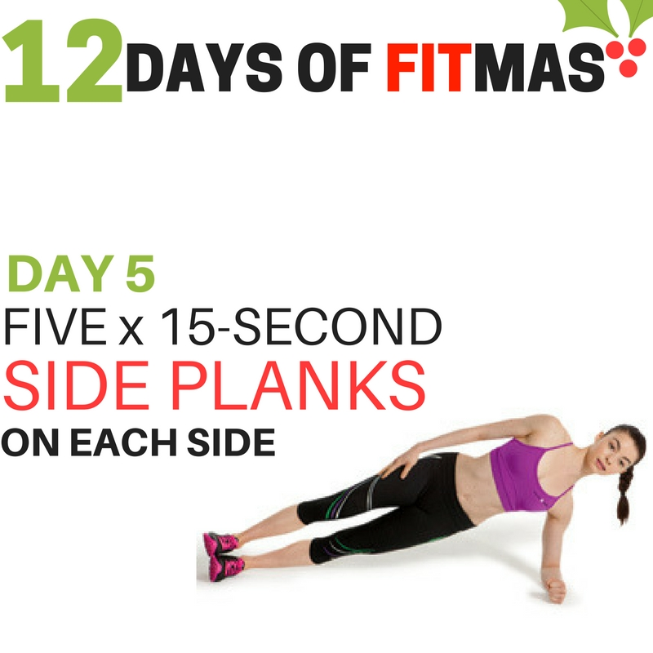

DAY 6: (When you complete the challenge, post a selfie and/or post a comment below 👇👇)

🎶On the SIXTH day of FITmas, the challenge I give to you: Six Star Jumps🎶

How? Stand with knees slightly bent and feet shoulder-width apart on a flat surface. Your arms should be slightly bent at your sides. Bend your knees to get into a squat position and jump vertically as high as you can. Extend your legs and arms fully out to your sides at the same time in midair to form a star shape with your body. Your arms should point upward at a 45-degree angle away from your head. Bring your arms and legs inward near your body as you begin to descend from the jump. Land softly on the ground with your knees bent. Repeat.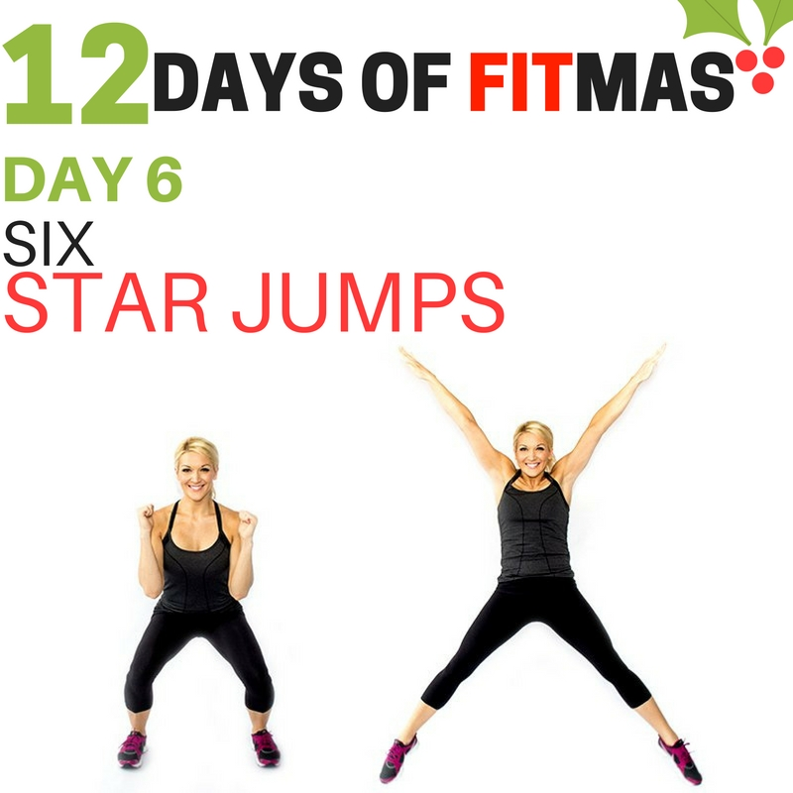
DAY 7: (When you complete the challenge, post a selfie and/or post a comment below 👇👇)

🎶On the SEVENTH day of FITmas, the challenge I give to you: Seven Chair Dips (repeat seven times)🎶

How? Place a sturdy chair in an open space. Sit down and wrap your fingers around the front edge of the chair. Slide your body forward until your buttocks is just off the chair. Start with your arms fully extended. Adjust your feet so your heels are a couple of inches in front of your knees. Bend your elbows to lower your body toward the floor. Point your elbows directly behind you; do not let them flare out to the sides. Stop when your elbows are at a 90-degree angle and press back up, straightening your arms.
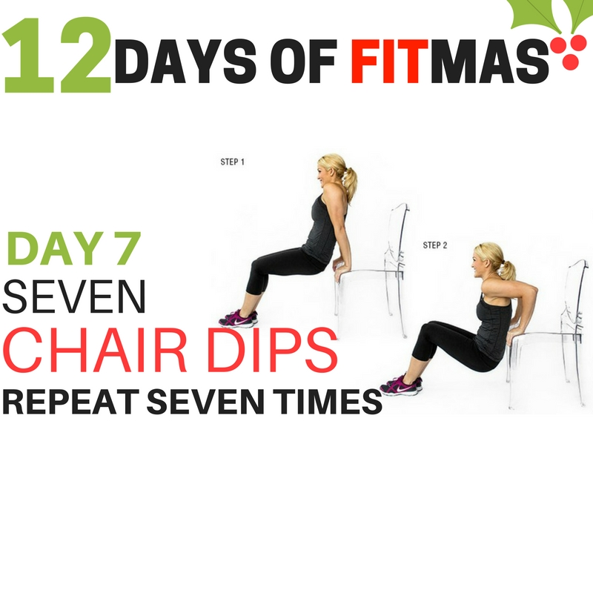
DAY 8: (When you complete the challenge, post a selfie and/or post a comment below 👇👇)

🎶On the EIGHTH day of FITmas, the challenge I give to you: Eight Lunges On Each Side (repeat four times)🎶

How? Keep your upper body straight, with your shoulders back and relaxed and chin up (pick a point to stare at in front of you so you don't keep looking down). Always engage your core. Step forward with one leg, lowering your hips until both knees are bent at about a 90-degree angle.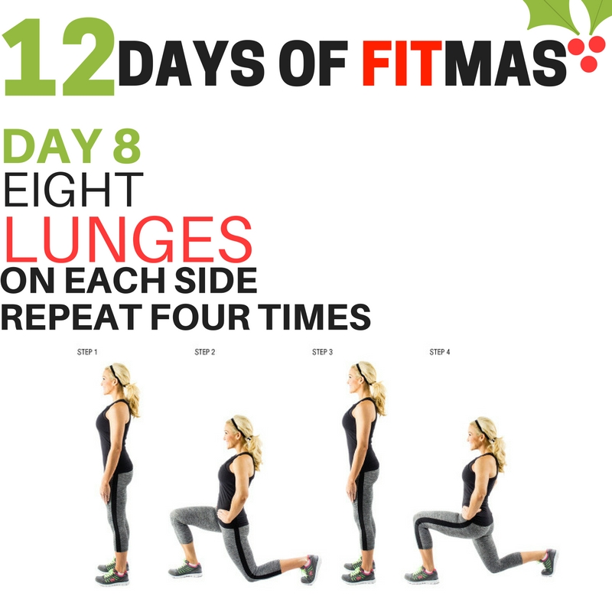
DAY 9: (When you complete the challenge, post a selfie and/or post a comment below 👇👇)

🎶On the NINTH day of FITmas, the challenge I give to you: Nine Push-Ups (repeat five times)🎶

How? Get into a high plank position. Place your hands firmly on the ground, directly under shoulders. Lower your body. Begin to lower your body—keeping your back flat and eyes focused about three feet in front of you to keep a neutral neck—until your chest grazes the floor. Push back up. Modify by dropping to your knees.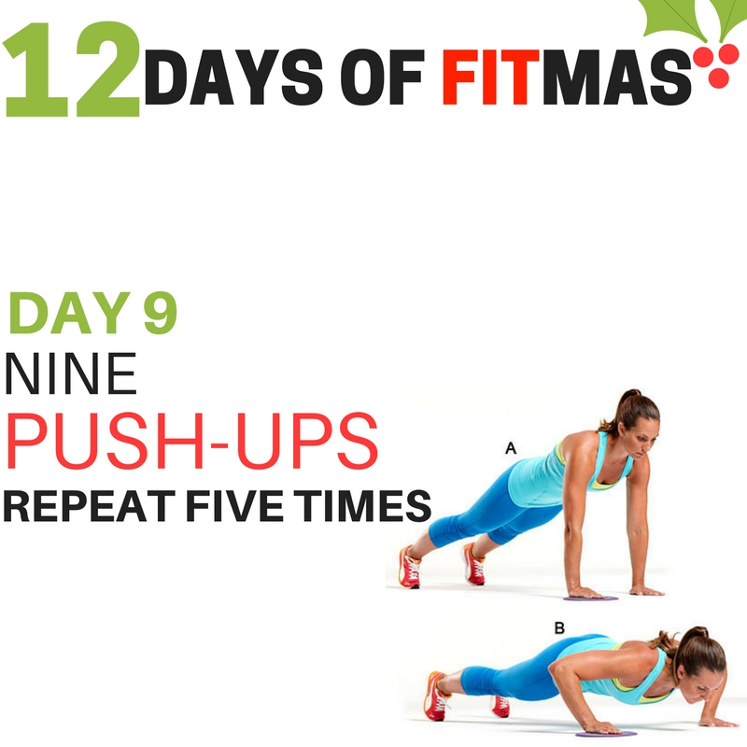

DAY 10: (When you complete the challenge, post a selfie and/or post a comment below 👇👇)

🎶On the TENTH day of FITmas, the challenge I give to you: Ten Squats (repeat five times)🎶

How? Place your feet shoulder-width apart or slightly wider. Extend your hands straight out in front of you to help keep your balance. You can also bend the elbows or clasp the fingers. Sit back and down like you're sitting into an imaginary chair. Keep your head facing forward as your upper body bends forward a bit. Rather than allowing your back to round, let your lower back arch slightly as you descend. Lower down so your thighs are as parallel to the floor as possible, with your knees over your ankles. Press your weight back into your heels. Keep your body tight, and push through your heels to bring yourself back to the starting position. 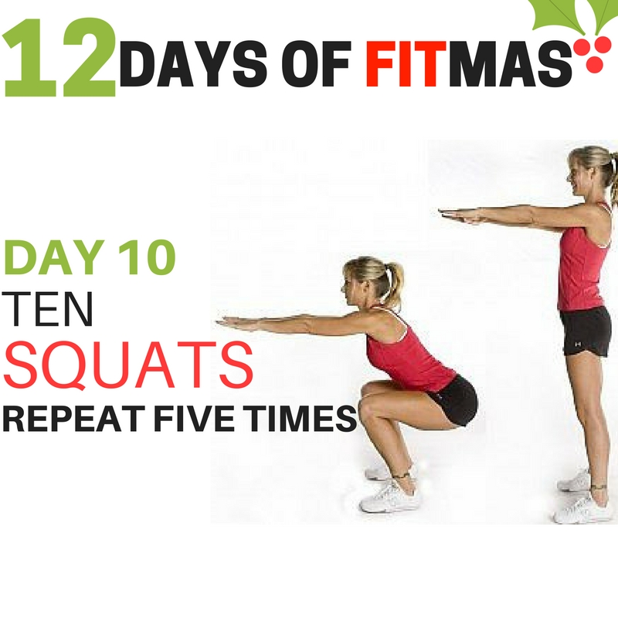
DAY 11: (When you complete the challenge, post a selfie and/or post a comment below 👇👇)

🎶On the ELEVENTH day of FITmas, the challenge I give to you: Eleven Mountain Climbers (repeat three times)🎶

How? Begin in a push-up position, with your weight supported by your hands and toes. Flexing the knee and hip, bring one leg until the knee is approximately under the hip. This will be your starting position. Explosively reverse the positions of your legs, extending the bent leg until the leg is straight and supported by the toe, and bringing the other foot up with the hip and knee flexed. Repeat in an alternating fashion.
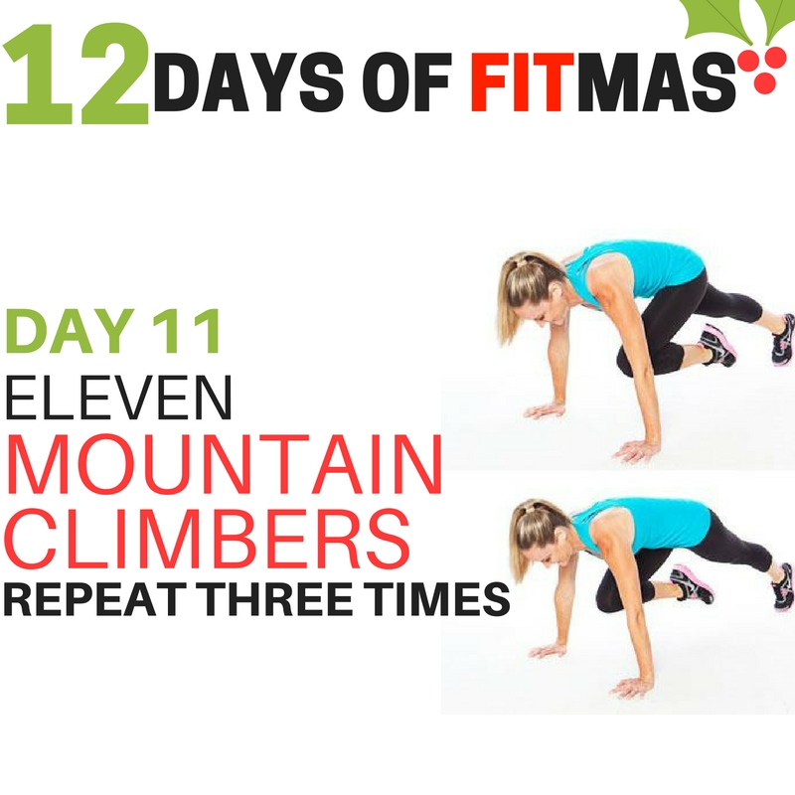
DAY 12: (When you complete the challenge, post a selfie and/or post a comment below 👇👇)

🎶On the TWELFTH day of FITmas, the challenge I give to you: Twelve High Knees (repeat five times)🎶

How? Stand straight with the feet hip width apart, looking straight ahead and arms hanging down by your side. Jump from one foot to the other at the same time lifting your knees as high as possible, hip height is advisable. The arms should be following the motion. Touch the ground with the balls of your feet.
